The Child's Own Country

There are many ways for children to learn the physical and political geography of their country. This is an educational requirement in probably all countries, so please make sure you are actively engaging your child in exploring the concepts below.

IMPORTANT: These concepts can be presented across several YEARS, starting in first or second year.

Material suggestions:
- Puzzle maps
- Paper/printable maps
- Pin maps
- Blank maps (with labels and control chart)
- DIY salt dough maps with pin labels
- Wall maps

You can use a variety of materials to mix up the activities and keep it fun.

Online resources:
Printable maps for all countries: https://www.d-maps.com
Online atlas: https://www.worldatlas.com/

Hard copy resources:
Oxford Atlas of the World

DIY United States map:
All Timeline users: watch the tutorial here!
- Print map here - 2 pages
- Trim and paste onto foam board or cardboard
- Print state and capital labels here
- Cut, fold, and glue onto quilting pins (suggested pins here)

Salt dough map activity: read about how to do this at home here.

EXPLORATIONS: These are not formal lessons, they are guided explorations.

The goals are:
- To introduce the use of an atlas (for research and for checking work)
- To learn the names of the geographic features of the child’s country
- Optional (age-dependent): To do further research independently

How to introduce these concepts:
You can adapt your lessons to fit how your child learns best. Some children like coloring maps, while others prefer pin maps or labels. Therefore, the explorations below don’t specify one approach. Isolate one concept at a time, so that the activities are short and the child can feel capable of repeating independently.

For younger children, you can create a control map and a working map. The control map has the answers, while the working map is blank (except for the concept you want them to learn highlighted in red) and has pins/labels, or has space for the child to write down their answers. Writing with pencil will allow the child to correct their errors when they check their work.

For older children (8+), it’s important to introduce the use of an atlas. They can use the atlas to research the concept they’re focusing on, as well as to check their work.

Exercises that highlight different concepts:

Exercises 1 & 2 don’t require much activity, they’re simply an orientation for the child.

1) The child’s country in the world: The country is set in red, the rest of the continent is in white, and the rest of the other continents are in tan.

2) The child’s country’s national capital (marked with a red star): The rest of the country is in white and the coastal waters are shown in blue. The capital is named on the control map. Provide information about the capital for the children. They can read books, write reports, or watch short videos about the capital.

3) The child’s country’s borders with neighboring countries: Each border should be marked in a different color. The colors should correspond to the puzzle pieces if you have a puzzle map of your continent. The child will label the names of the neighboring countries and check their work.

4) The child’s country’s coastlines (the names of the seas that surround the country): Mark the coastlines in red. The rest of the map is in white and the waters are shown in blue. The child will label the names of the seas that surround their country, and check their work. The child can research information about these seas as follow-up work (optional).

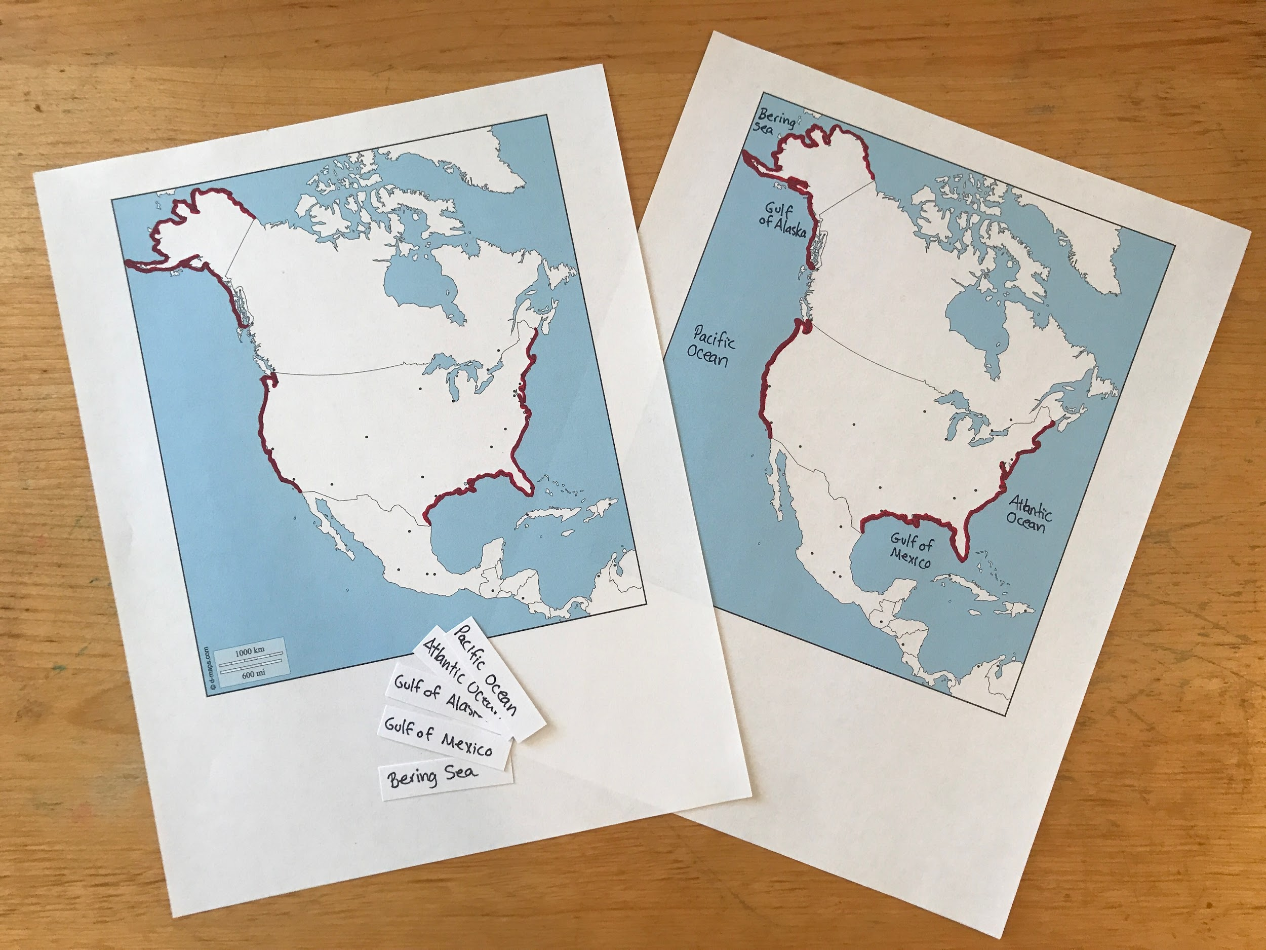
These maps were printed from www.d-maps.com, highlighted in red with Sharpie, and the labels are handmade. You don’t have to spend a lot of money or time to teach these concepts.

5) The child’s country’s gulfs: The gulfs are highlighted in the color that corresponds to the sea (from map #4). The rest of the map is in white and the coastline is in white. The child will label the names of the gulfs and check their work. The child can research information about these gulfs as follow-up work (optional).

6) The child’s country’s ports: The ports are in red. The rest of the map is in white with blue coastal waters. The child will label the names of the ports and check their work. The child can research information about these ports as follow-up work (optional).

7) The child’s country’s islands map: The islands nearest the child’s country will be marked in red. The rest of the map is in white with blue coastal waters. The child will label the names of the islands and check their work. The child can research information about these islands as follow-up work (optional).

8) The child’s country’s channels and straits: They are highlighted in red. The rest of the map is in white with blue coastal waters. The child will label the names of the channels and straits and check their work. The child can research information about these channels and straits as follow-up work (optional).

9) The child’s country’s tallest mountains: They are marked by triangles and highlighted in red. The rest of the map is in white with blue coastal waters. The child will label the names of the tallest mountains and check their work. The child can research information about these mountains as follow-up work (optional).

9a,b,c,d,e, etc.) Each mountain range examined individually: blank maps + loose slips (of individual mountains for each range). The child will use the atlas to find and label the mountain ranges. The child can research information about these mountain ranges as follow-up work (optional).

10) The child’s country’s volcanoes: They are marked by triangles and highlighted in red. The rest of the map is in white with blue coastal waters. The child will label the names of the volcanoes and check their work. The child can research information about these volcanoes as follow-up work (optional).

11) The child’s country’s plains: They are highlighted in green. The rest of the map is in white with blue coastal waters. The child will label the names of the volcanoes and check their work. The child can research information about these volcanoes as follow-up work (optional).

12) The child’s country’s rivers and main tributaries, plus the mountains from which they originate: They are all marked in blue. The rest of the map is in white with blue coastal waters. The child will label the names of the rivers and tributaries and check their work. The child can research information about these rivers as follow-up work (optional).

12c) The mountains that are connected to the rivers: The child will label the names of the mountains and check their work. The child can research information about these mountains as follow-up work (optional).

13) The child’s country’s lakes: They are highlighted in blue. The child will label the names of the lakes and check their work. The child can research information about these lakes as follow-up work (optional).

14) The child’s country’s depressions/lagoons: They are highlighted in dark blue. The child will label the names of the lagoons and check their work. The child can research information about these lagoons as follow-up work (optional).

15) The child’s country’s tunnels, roads, railways (as required by interests or standards)

16) The child’s country divided into states/regions/provinces: Each state shows the state symbol (flower, coat of arms). It can be fun to play states bingo to identify each state, or play matching games for the states’ flower and coat of arms.

United States bingo (variety of options)

17) Historical aspects of regions: Important wars, treaties, annexations, cessations, and migrations can be marked on a map to show where they took place. The child can research information about these events and regions as follow-up work (optional).

Criteria for organization:

First group: 0-8
Location of the child’s country in the world, boundaries, coastal and marine features

Second group: 9-11
Vertical configurations (relief forms) including volcanoes

Third group: 12-14
Hydrosphere: rivers, lakes, lagoons

Fourth group: 15-16
Transport and communication (human work is included)

Fifth group: 17
Historical aspect of regions

After this work, if the child wants to know more, he can research in an atlas.

Important: Each aspect is found in isolation (isolation of difficulty)

Considerations for preparing the material:
- From the general to the particular.
- Provide isolation of difficulty.
- Respect logical connections (for example, ports are examined after gulfs)
- Blank material is necessary whenever the children are expected to memorize.

We also need to help the children see their country from an economic perspective - economic geography. (see Timeline for these lessons)

